**IPV6 (internet protocol version six)**

**Internet is a network of network through which billions of devices are connected with each other and according to one estimates the size of internet becomes double after each nine month.**

**As discussed earlier in IPV4 we have 32 bit so the total number of IP addresses that can be used are about 4.8 billion that’s are not enough to support every device that is connected to internet .**

**The 32-bit Ip addressing scheme involves a two level addressing hierarchy**

1. **Network number/prefix**
2. **Host number**

I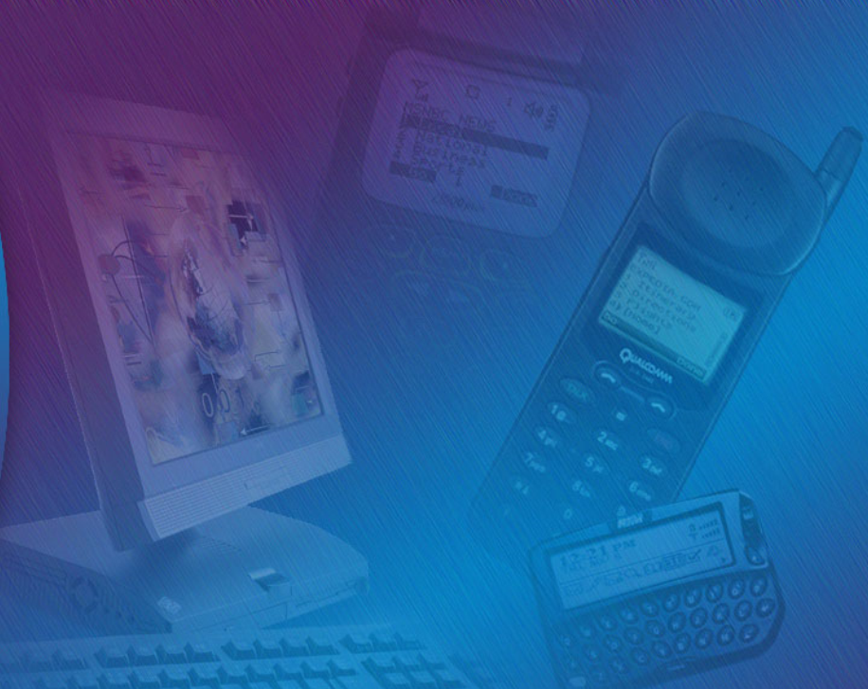

In order to overcomes the shortages of IPV4(internet protocol version four) adddressing schemes IPv6(internet protocol version six ) was introduced.

The main features of IPV6 includes

* Large address space because it has 128 bits unline IPv4 which has 32 bit so the total number of IPV6 addresses that can be supporte are (2^128).
* Efficient backbone routing
* Security(Ip security Is enabled by default so when two devices using IPV6(inetrnet protocol version six) communicate a secure tunnel is formed among them .
* It has better support for quality of service.

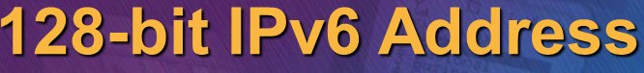

IPv6 (internet protocol version six is consisting of 128 bits) and it has eight blocks each block is consisting of 16 bits and each block is separated with other block with  **:**  Symbol.



One rule that must be followed is that Leading Zeros will be removed and will be replaced with:: symbol

And remember it can be done only one in IPV6 address meaning that we cannot have (:: ) symbol two times.



**The Difference between IPv4 and IPv6**

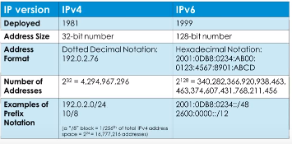

**Link local address**

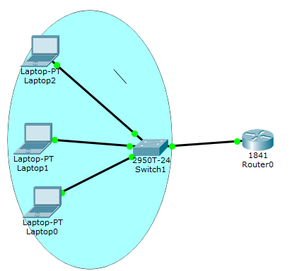**Link local address is network address that can be used only inside the network it can’t be routed outside .The packets sourced from or destined to link local address are not forwarded out of layer two domains by the router. So if we are dealing with link local address these packets will remain inside the network in the above given example PC1, PC2, and PC3.**

**Types of IPV6 addresses**

**IPV6 (internet protocol version six) has three types of addresses.**

* **Unicast –address (one to one) : A packet is delivered to only one interface.**
* **Multicast-address (one to many) : A packet destined to multiple interfaces.**
* **Any-cast (one to nearest) : A packet is delivered to nearest of multiples interfaces.**

**Unlike IPV4 (internet protocol version four) IPV6 (internet protocol version six) did not support broadcast address.**

**Global Unicast –addresses**

**The Global unicast address is globally unique on the internet this types of addresses starts with 2000 :: /3 .**

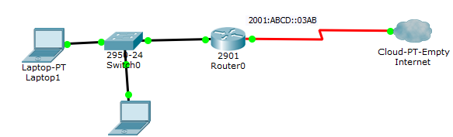

**The Global unicast addresses are assigned by ISP (internet service provider) two devices can’t have same IP address in the world.**

**Loopback address in IPv6**

**Like in IPV4 the loop back address is (127.0.0.1) in order to check the connectivity we use the command ping 127.0.0.1 to check the connectivity. In IPV6 the loopback address is 0000:0000:0000:0000:0000:0000:0000:0001 so it can be rewritten as ::1. To check your connectivity to your network interface card just ping ::1 in cmd.**

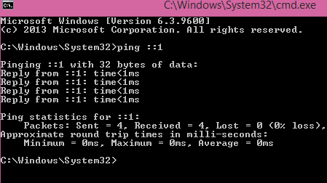

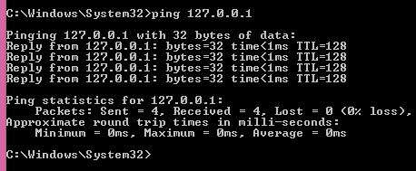

**In order to check the IPV6 (internet protocol version 6) address being used on your pc. Enter the command “ipconfig” without quote.**

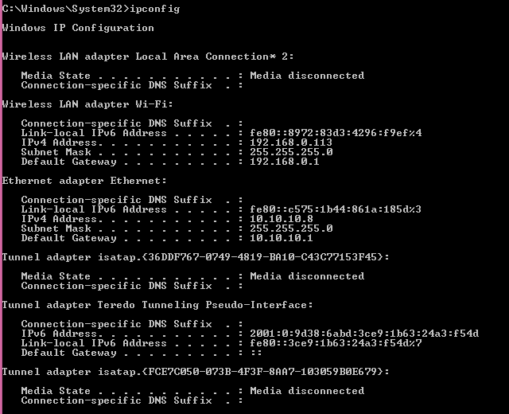

**How to enable IPv6 (internet protocol version 6 ) on Windows Operating systems.**

**In order to check either IPv6 (internet protocol version six) in window XP based systems is already enabled on your system type the command “ipv6 /?” in command prompt.**

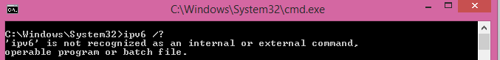

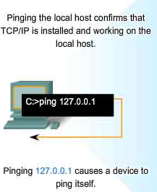

**The output shows ipv6 is not recognized because still we have not enabled IPV6 support on the PC.**

**In order to make your PC to support IPv6 (internet protocol version six) follow these simple steps**

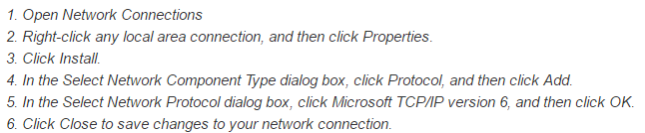

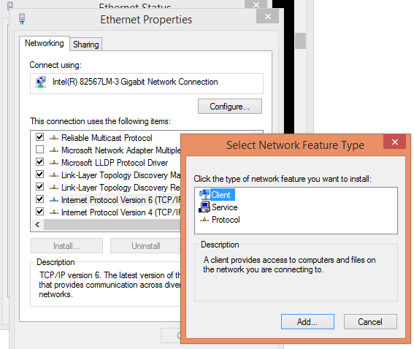

**If IPv6 (internet protocol) DHCP (Dynamic host configuration) is configured properly then follow these following steps to get the IPV6 address.**

**Go to Ethernet Status then click on properties in the second window click on properties again.**

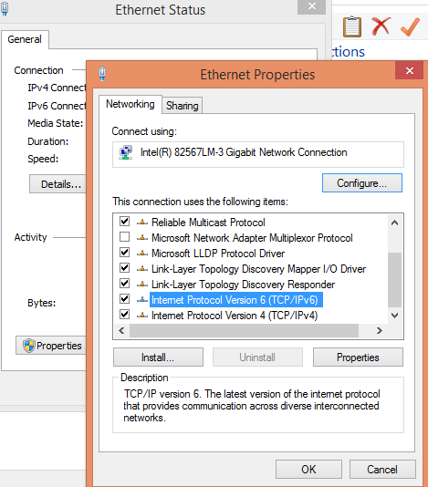

Select the Radio button “obtain ipv6 address automatically” and these addresses will be obtained from DHCP (dynamic host configuration protocol) or even can be configured manually.

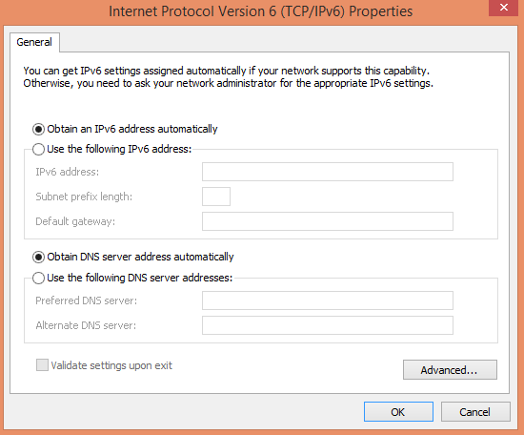

**Quick quiz**

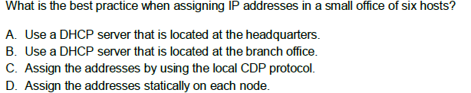

**Answer: D**



**What is the usage of any cast address?**

1. For Load balancing
2. To communicate with a group of host.
3. It is same like broadcast address
4. None of Given option

**Answer B: Any-cast is networking technique where the same IP prefix is advertised from multiple locations. The network then decides which location to route a user request to, based on routing protocol costs.**